Aim :
To convert a given string into a 32-bit signed integer by ignoring leading spaces, handling optional sign (+ or -), reading numerical digits, and ensuring the result lies within the integer range.
ALGORITHM (Short Version)
- If the string is null or empty, return 0.
- Skip all leading white spaces.
- Check for optional sign (+ or -) and set sign accordingly.
- Read digits one by one and form the number.
- If overflow occurs, return Integer.MAX_VALUE or Integer.MIN_VALUE.
- Return the computed integer with sign applied.
Program :
class Solution {
public int myAtoi(String s) {
if (s == null || s.length() == 0) {
return 0;
}
final int INT_MAX = Integer.MAX_VALUE;
final int INT_MIN = Integer.MIN_VALUE;
int i = 0;
int n = s.length();
while (i < n && s.charAt(i) == ' ') {
i++;
}
if (i == n) {
return 0;
}
int sign = 1;
if (s.charAt(i) == '+') {
i++;
} else if (s.charAt(i) == '-') {
sign = -1;
i++;
}
long res = 0;
while (i < n && Character.isDigit(s.charAt(i))) {
int digit = s.charAt(i) - '0';
res = res * 10 + digit;
if (sign * res <= INT_MIN) {
return INT_MIN;
}
if (sign * res >= INT_MAX) {
return INT_MAX;
}

i++;
}
return (int)(res * sign);
}
}

Output :
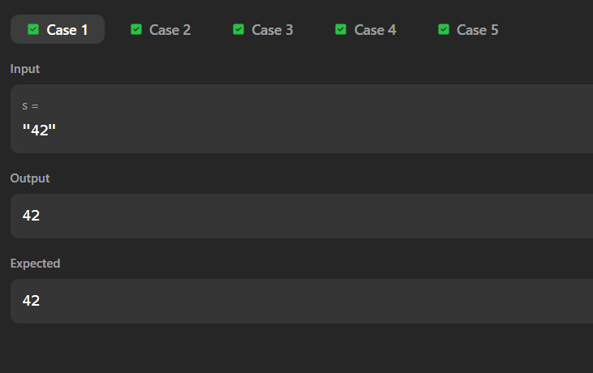

Aim
The objective is to find the minimum number of deletions required to transform a given string (containing only characters 'A' and 'B') into a string where no two adjacent characters are identical. Essentially, we want to ensure the string alternates perfectly between 'A' and 'B'.
Algorithm
- Initialize: Set a counter deletions = 0.
- Iterate: Loop through the string from index $i = 0$ to $n-2$.
- Compare: Check if the current character $s[i]$ is the same as the next character $s[i+1]$.
- Count: If they match ($s[i] == s[i+1]$), increment deletions.
- Result: Return the final deletions count.
Program :
import java.util.Scanner;
public class Solution {
public static int alternatingCharacters(String s) {
int deletions = 0;
for (int i = 0; i < s.length() - 1; i++) {
// If adjacent characters are the same, we must delete one
if (s.charAt(i) == s.charAt(i + 1)) {
deletions++;
}
}

return deletions;
}
public static void main(String[] args) {
Scanner sc = new Scanner(System.in);
int q = sc.nextInt(); // Number of queries
while (q-- > 0) {
String s = sc.next();
System.out.println(alternatingCharacters(s));
}
sc.close();
}
}
Output :
